Skill 5,6 & 7:
- To Apply Single Quotes, Preserve Literal Content, Ignore Variable Expansion, Store Quoted Strings, Validate Parsing Results, Test Edge Cases.
To Apply Double Quotes, Preserve Spaces, Allow Variable Expansion, Parse Nested Tokens, Validate Outputs, Test Quoted Commands.
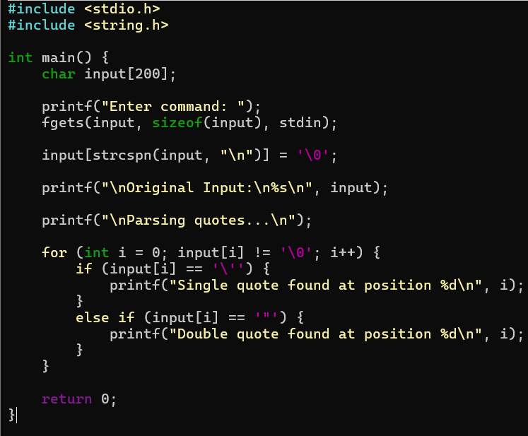
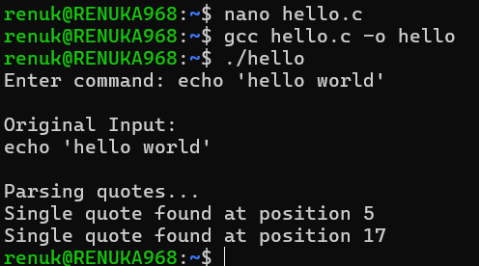
- To Create Process Escape Sequences, Handle Escaped Spaces, Escape Special Symbols, Preserve Characters, Validate Parser Output, Test Complex Inputs.
To Create Child Processes, Execute Programs, Handle Execution Errors, Pass Arguments, Manage Parent Process, Test Command Launching.

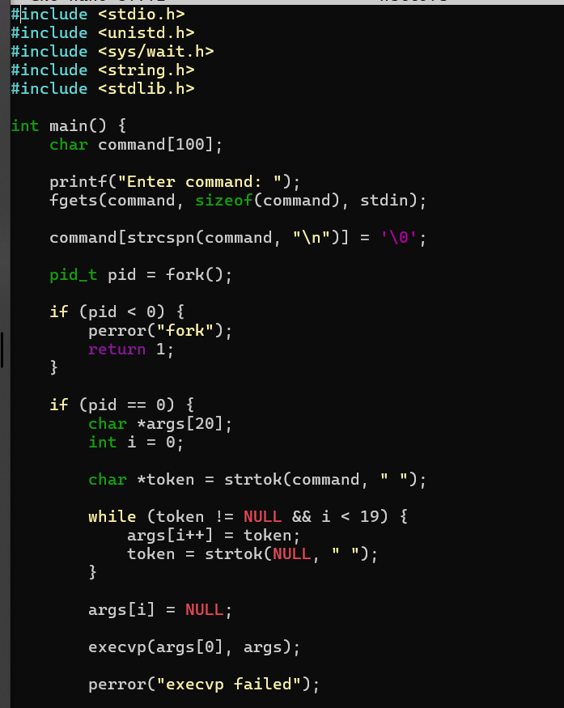
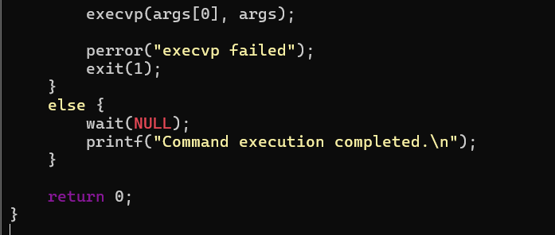
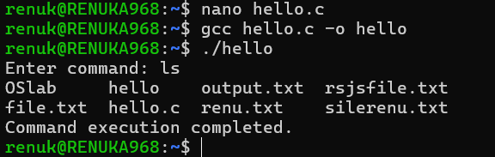

- Process Synchronization and Child Process Monitoring Using waitpid().
To Retrieve PATH Variable, Parse Search Directories, Locate Executables, Verify Permissions, Handle Missing Commands, Test Command Resolution.
